KIDGAMES PROJECT

Index page:

1- cover page of project

2-the user start from this page

3- when click on the menu of right corner will appear the list of option (products –login-logout –register-information about project –explanation of project ).

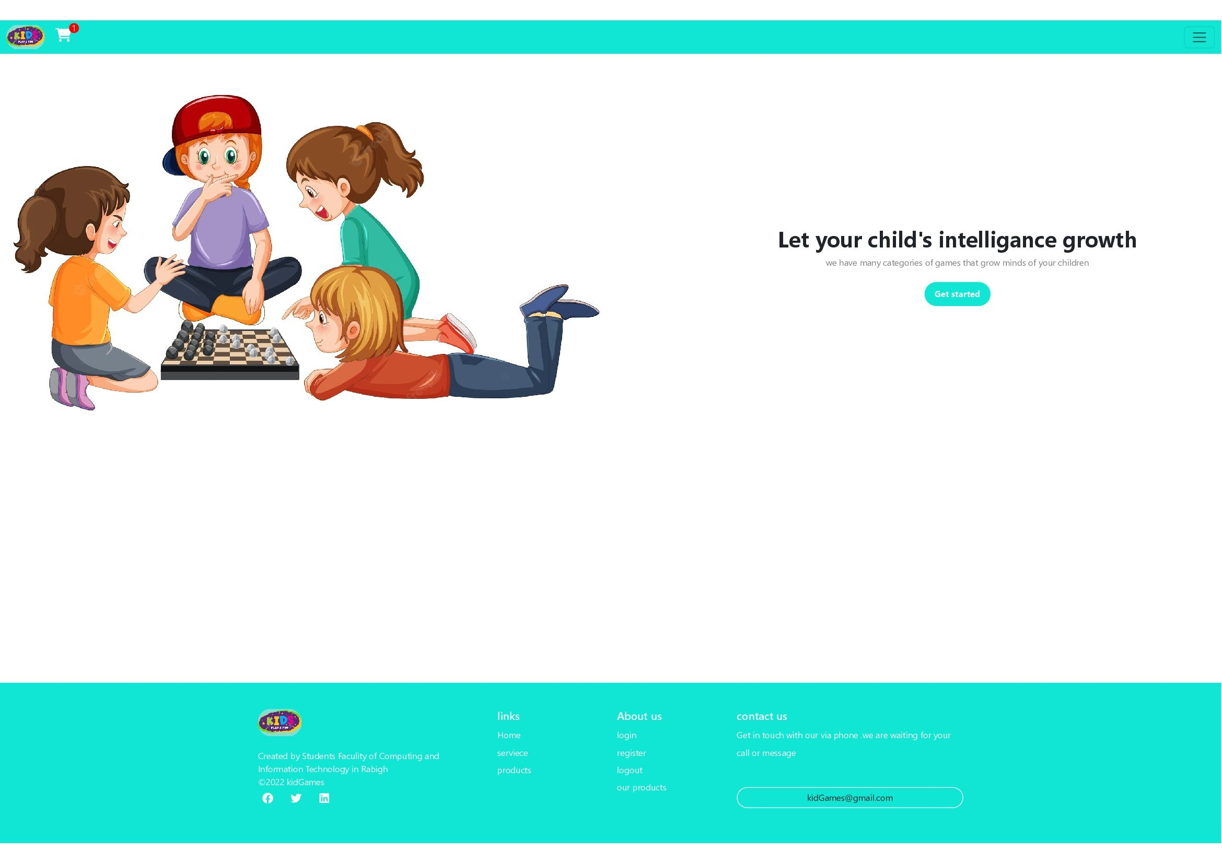

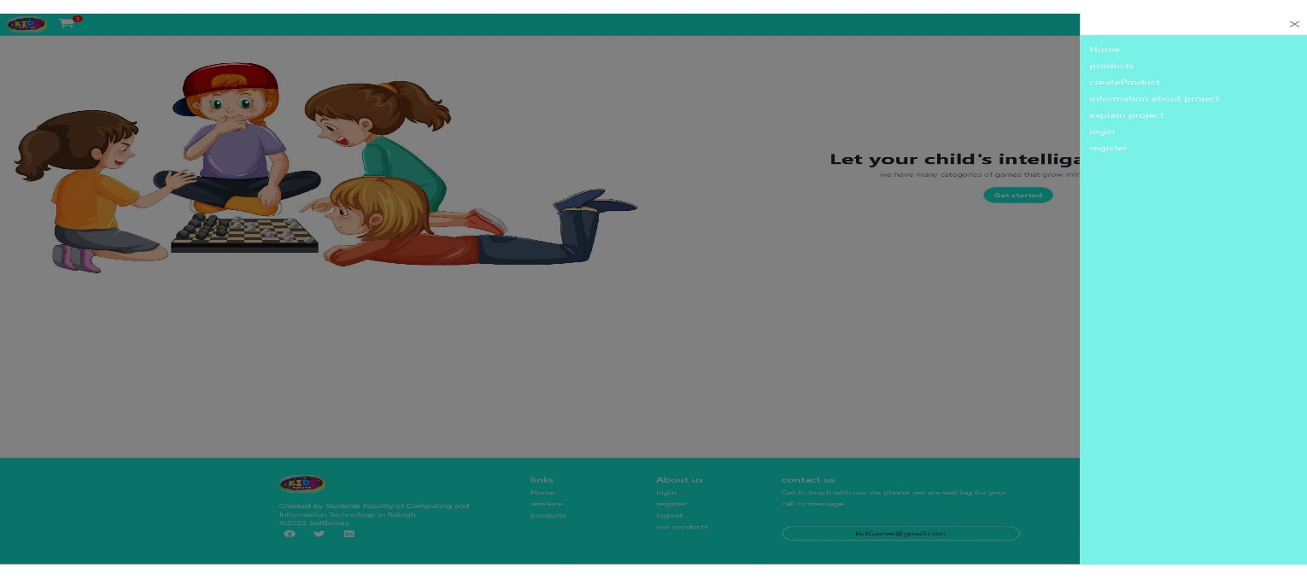

Products page:

1-contain of the all products and category

2- the customer can choose products from this page.

3-also can search about products here by prices or title

4- admin can edit or delete product from this page.

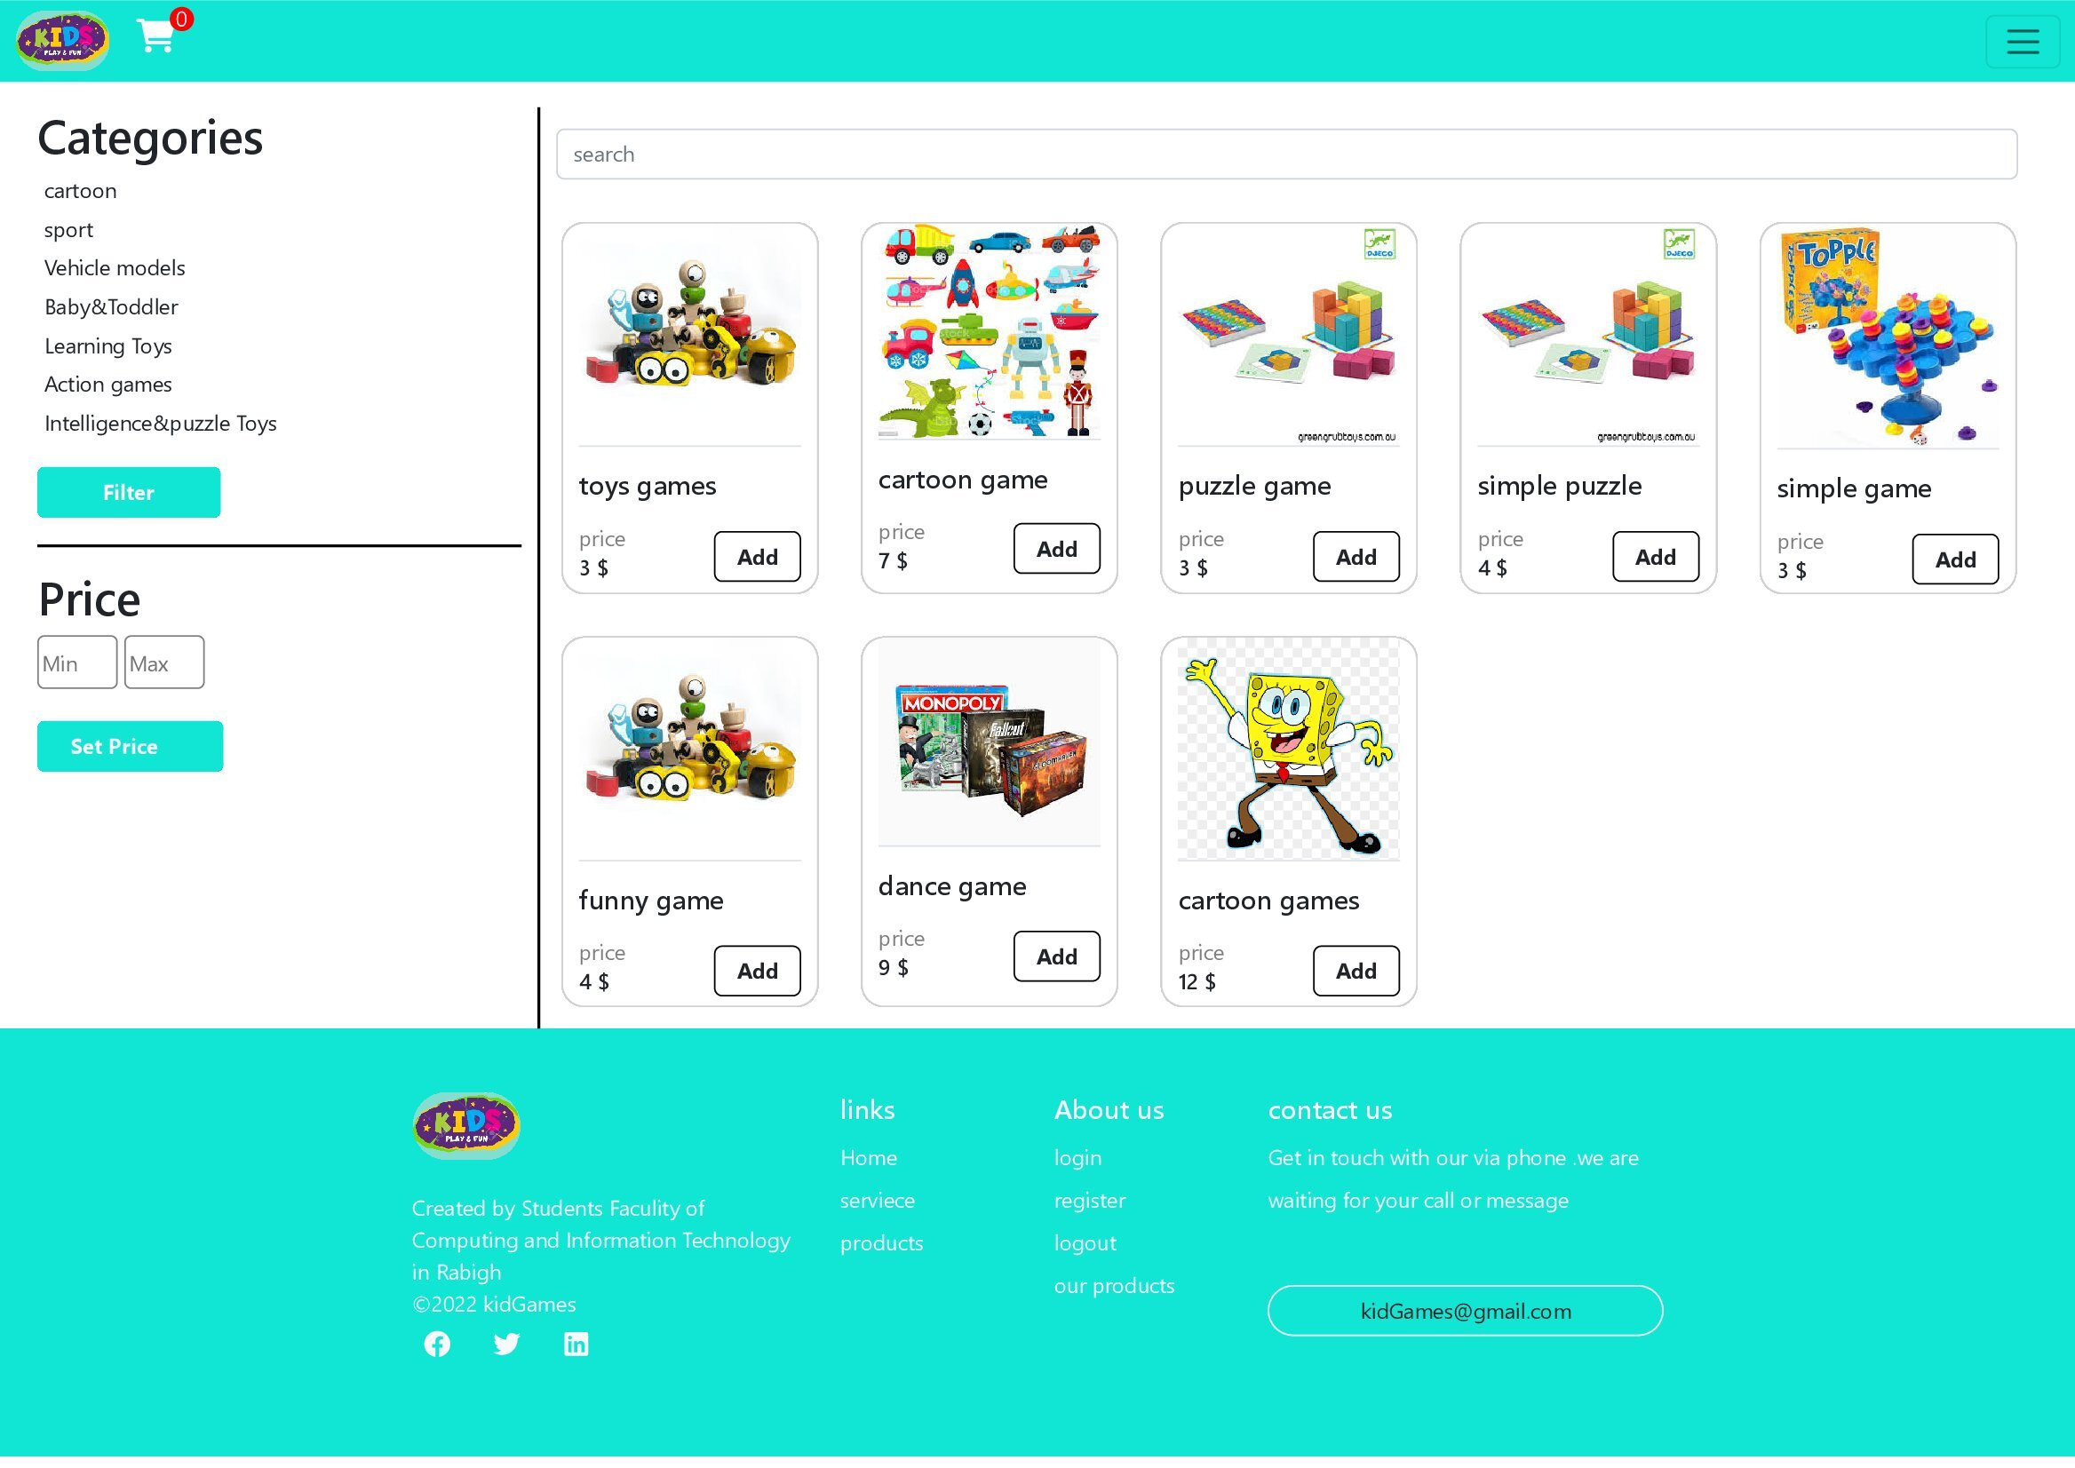

When user click on the "Add" button the next page apeare

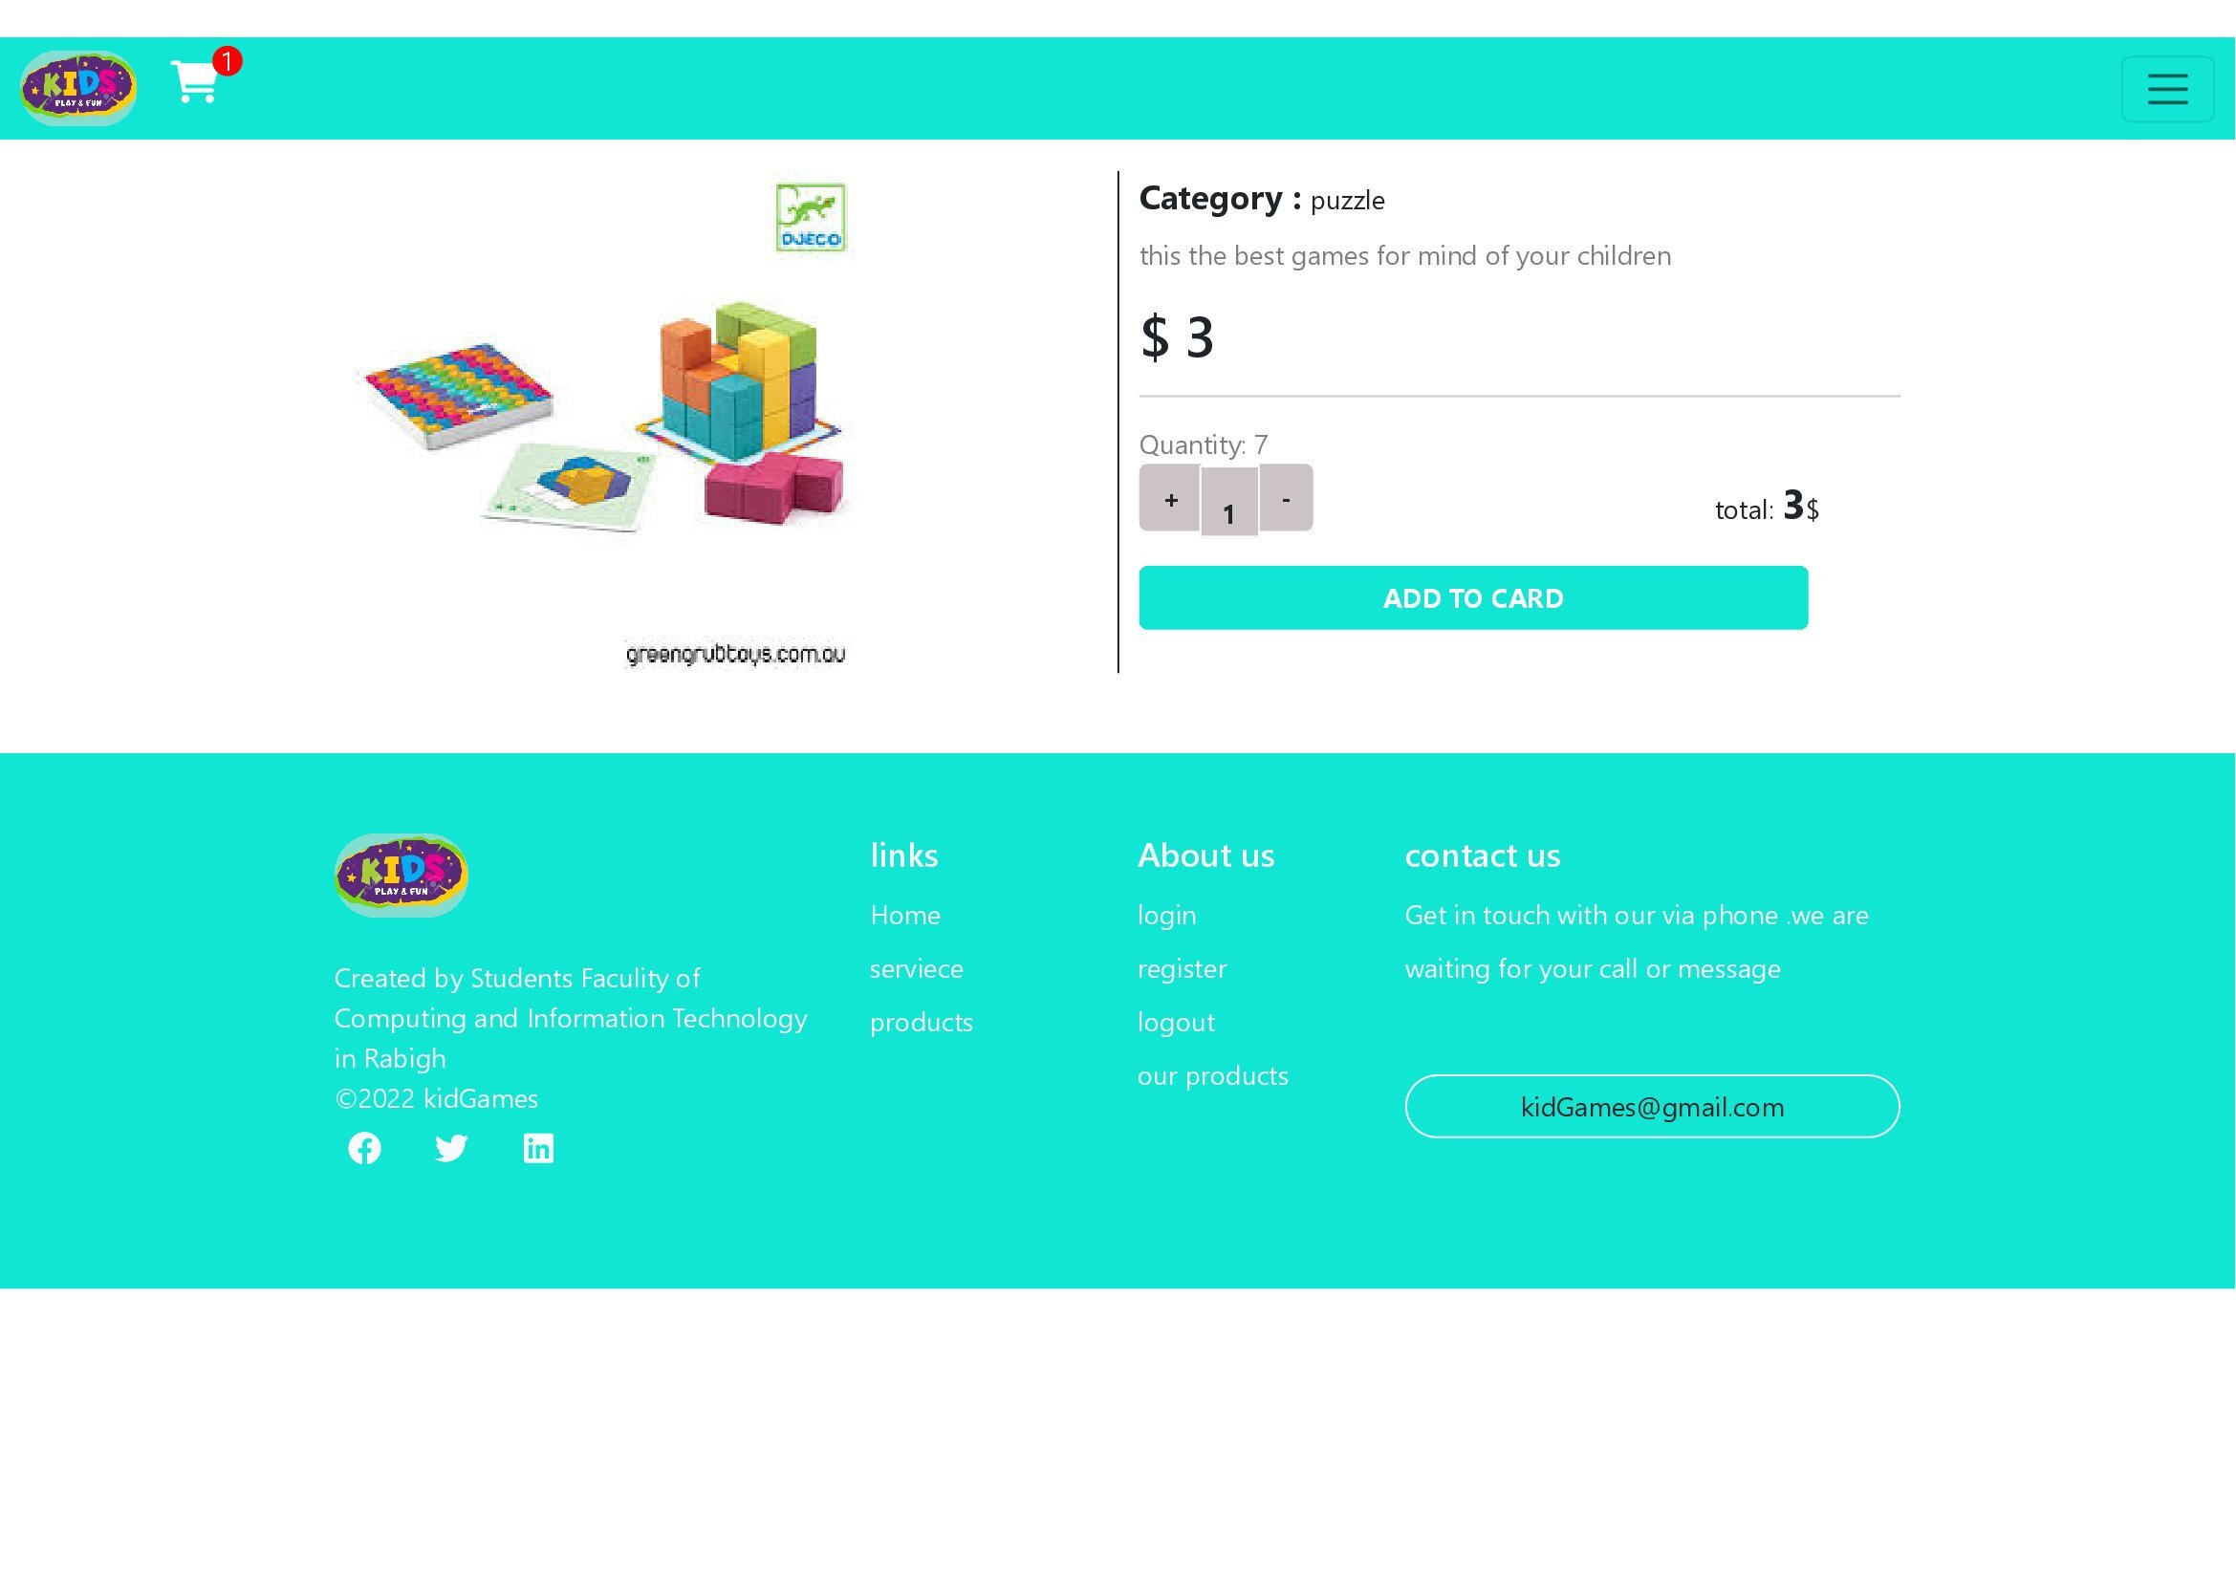

From the above page the user can :

1- increase the number of product quantity want .

2- add the product to the cart .

3- see the description of product choosen.

Cart page:

1-show the product that the user selected or he want.

2- increase or decrease the number of quantity .

3- see the number of product selected

4- cancel the product from cart.

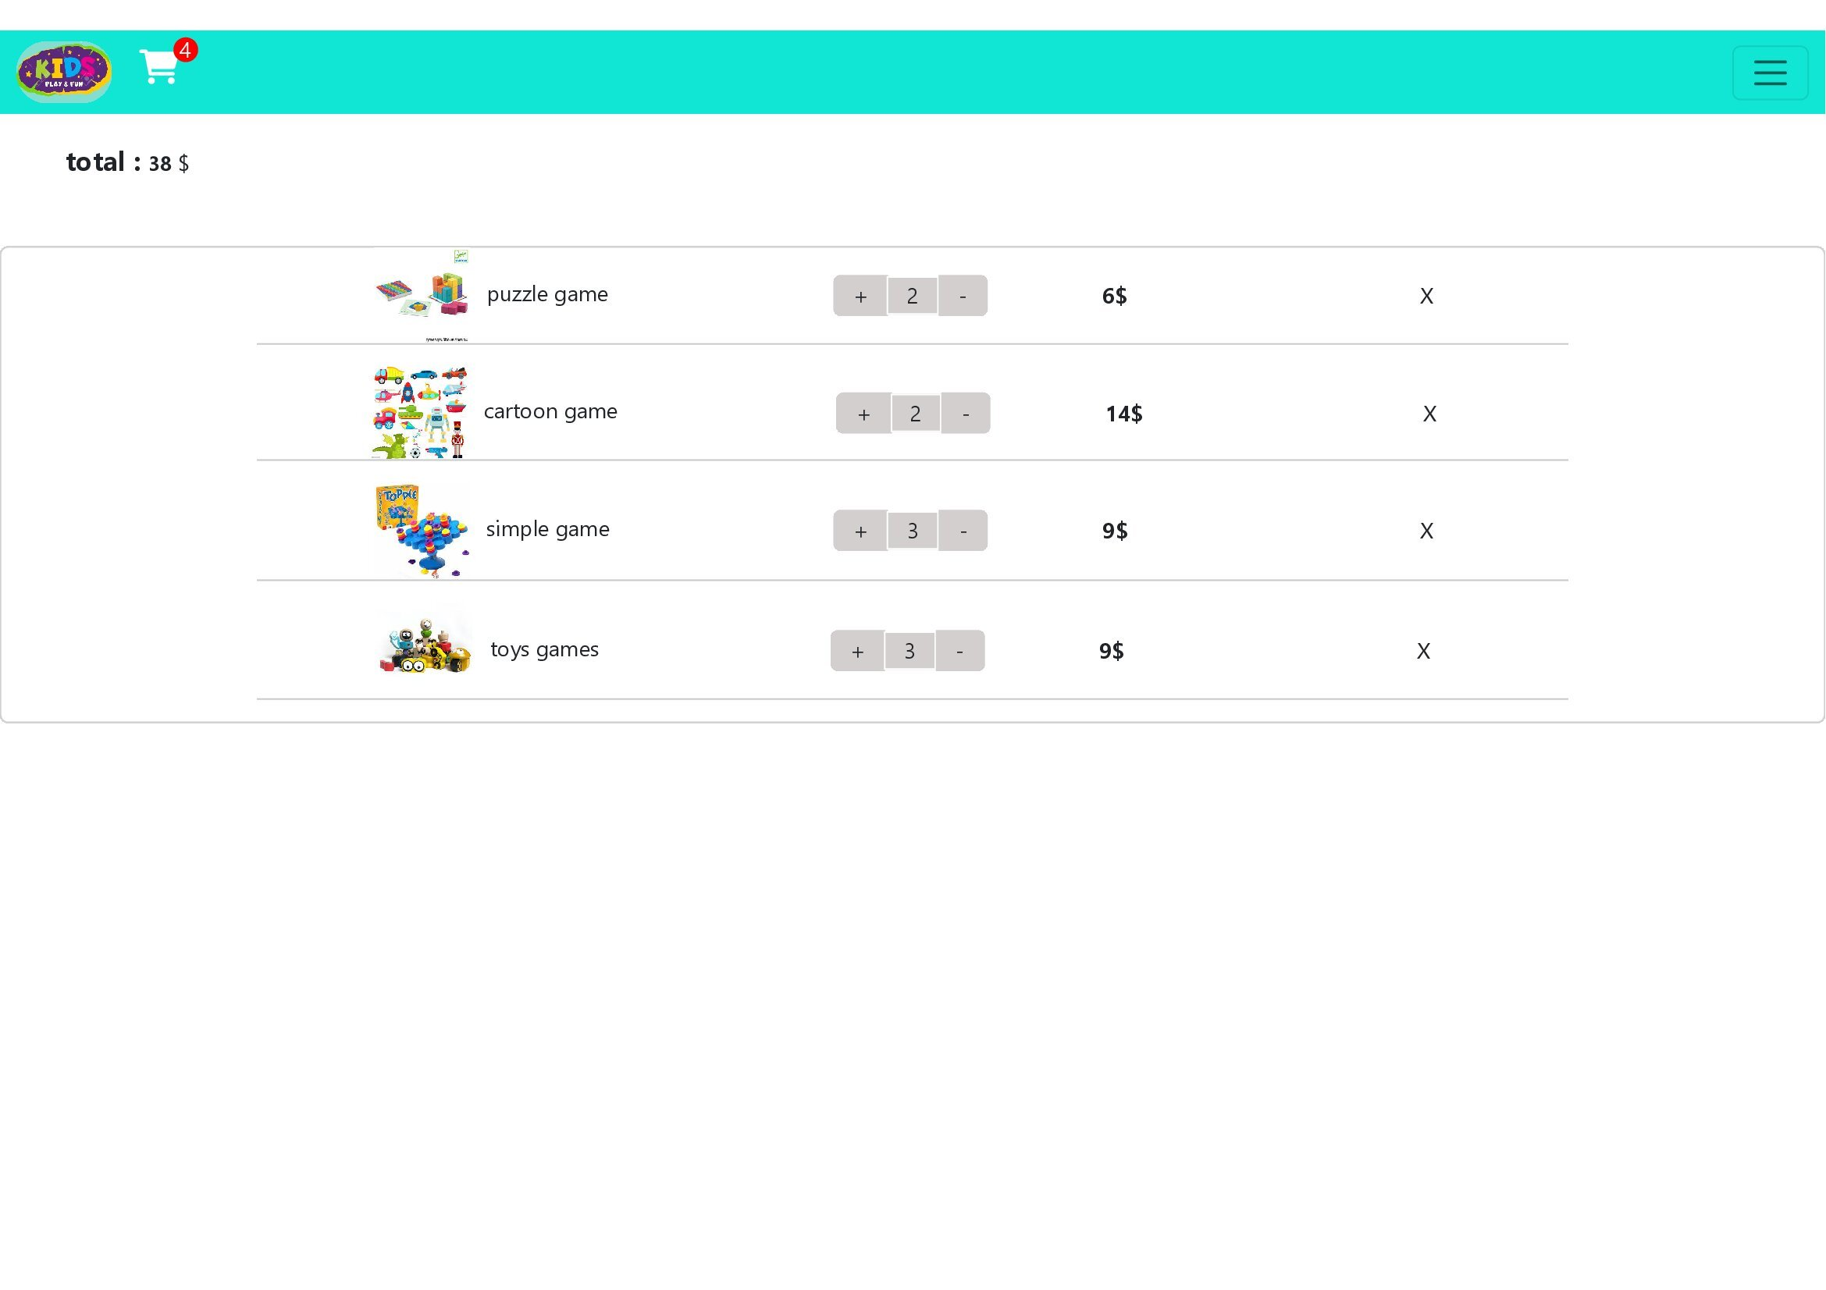

Login page:

1-when user click add button if the user has account in our database the product adding , but if he don't has account in database the website will move him to the login page or regiser page.

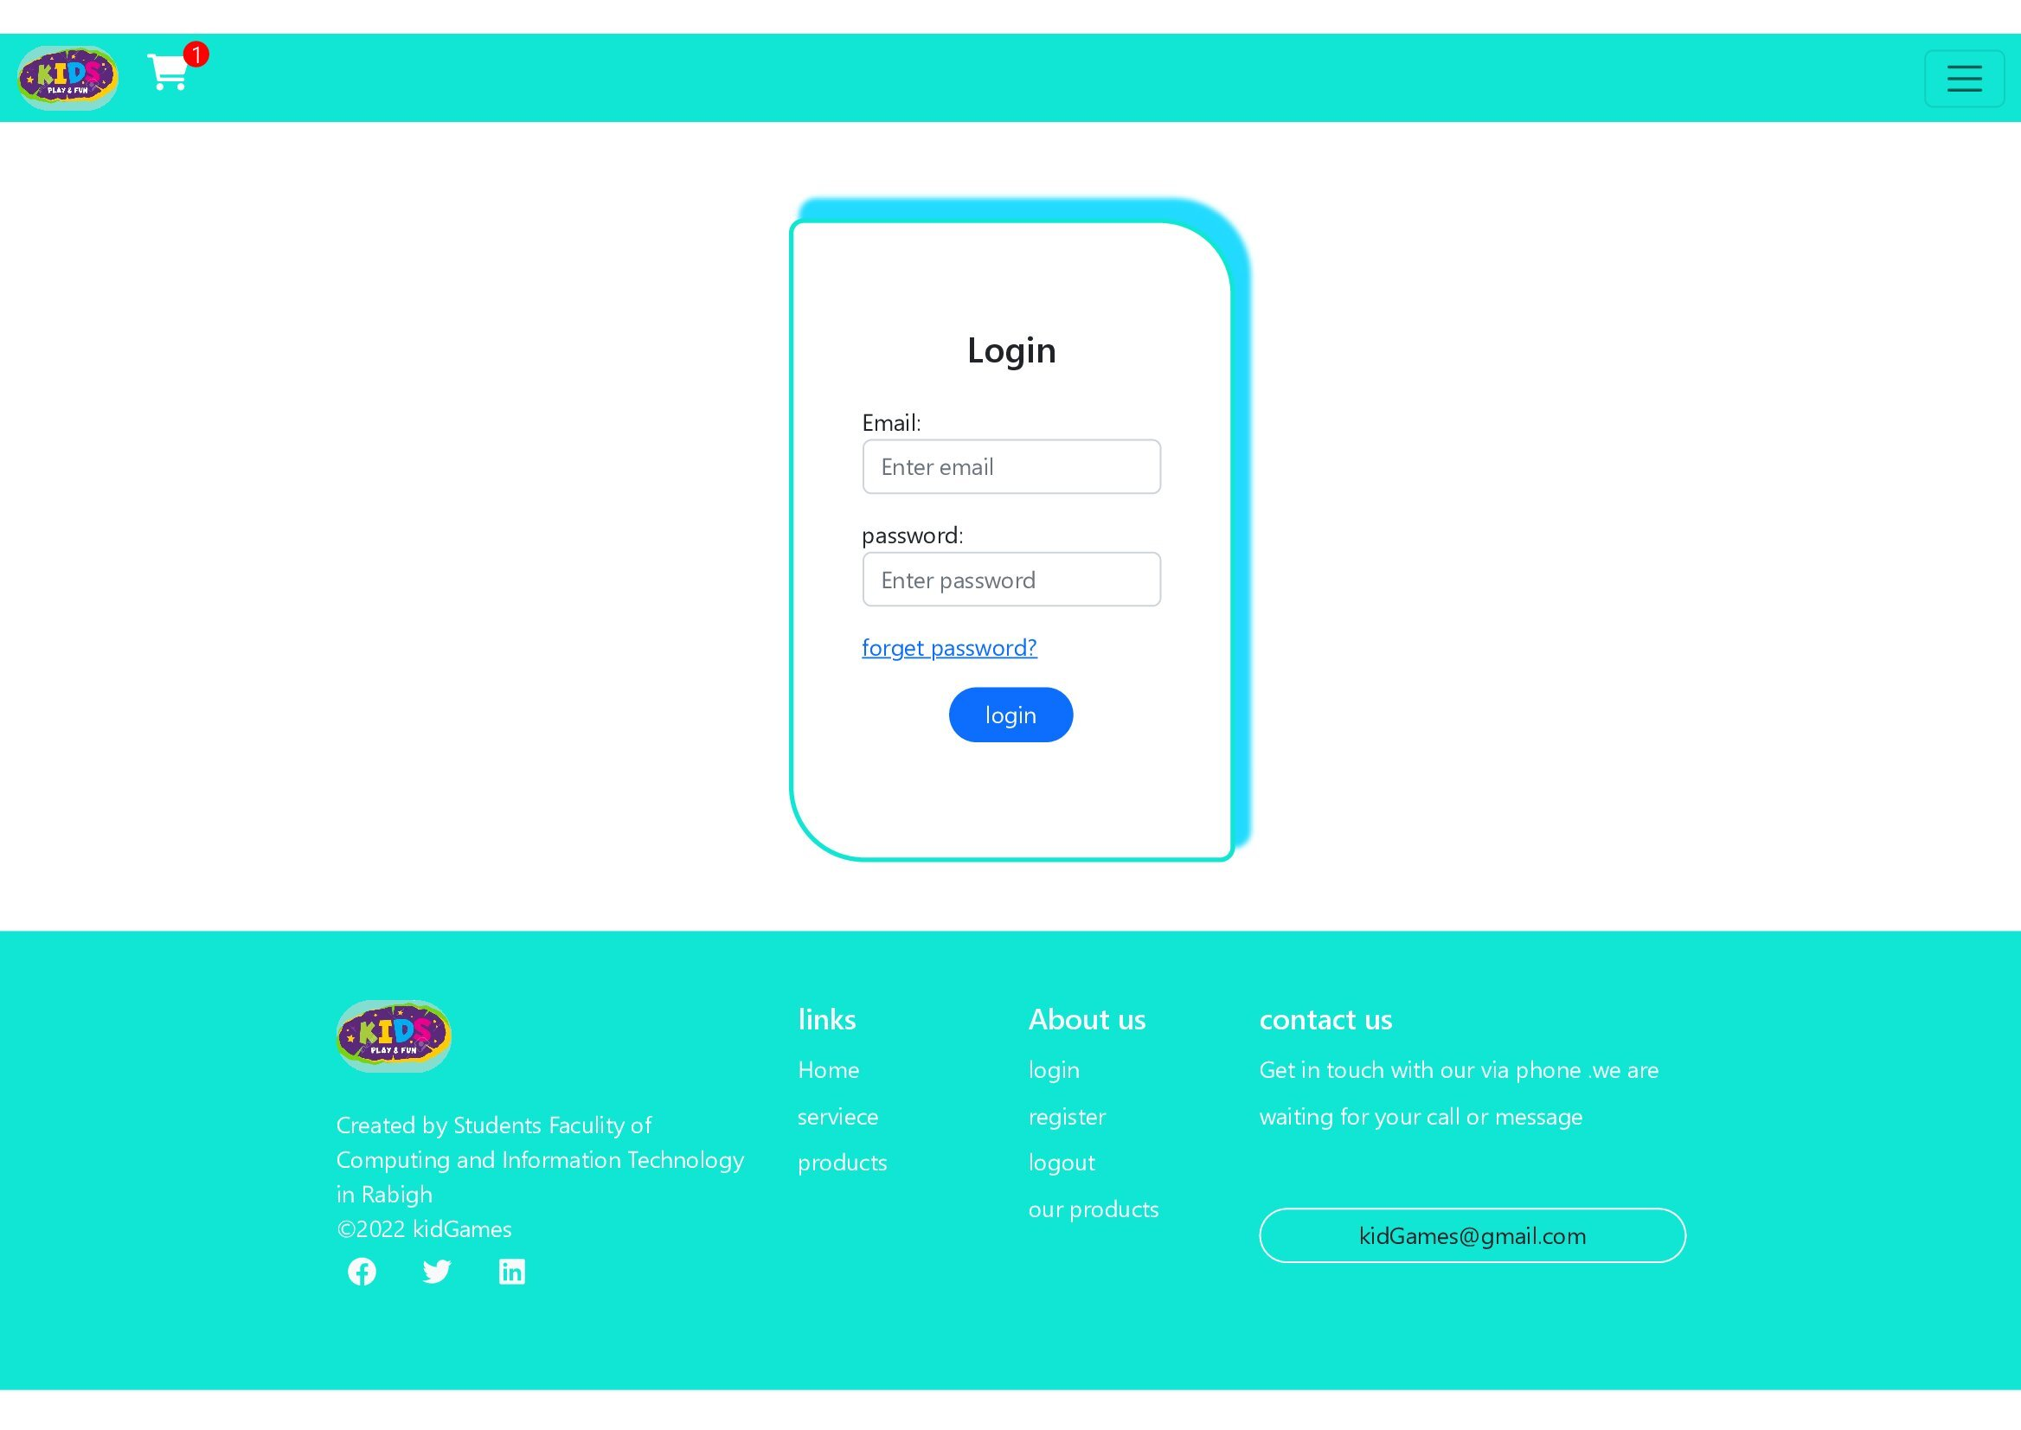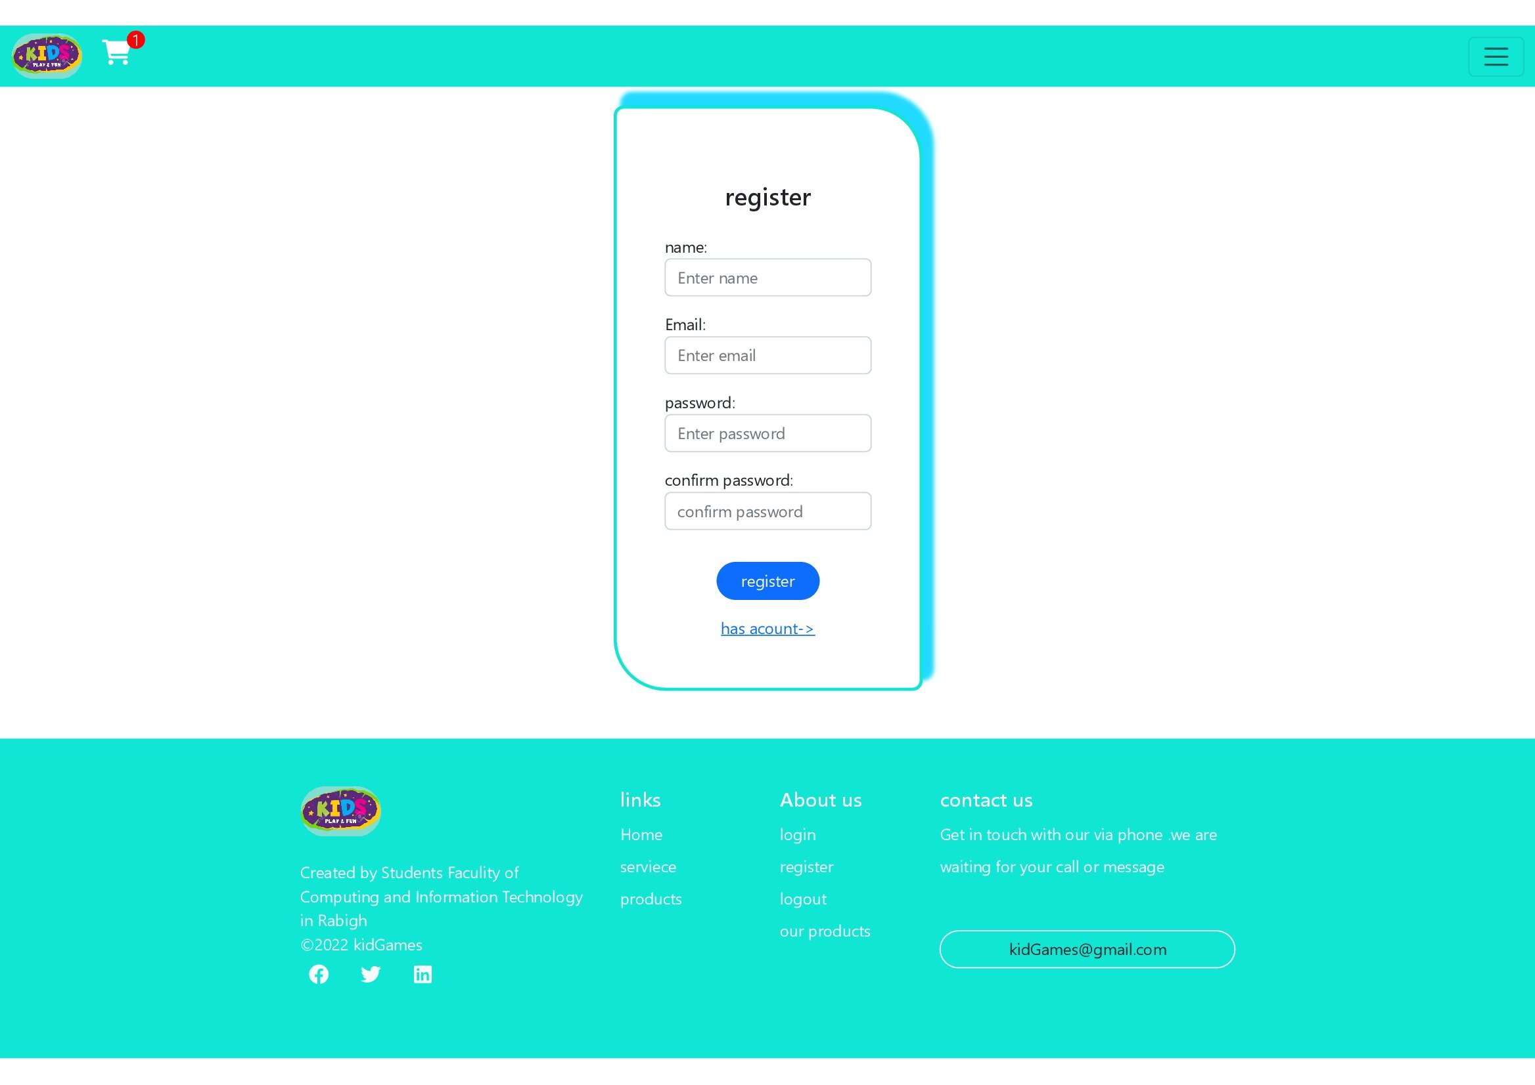

Create product page:

1-the admin can create the product from this page

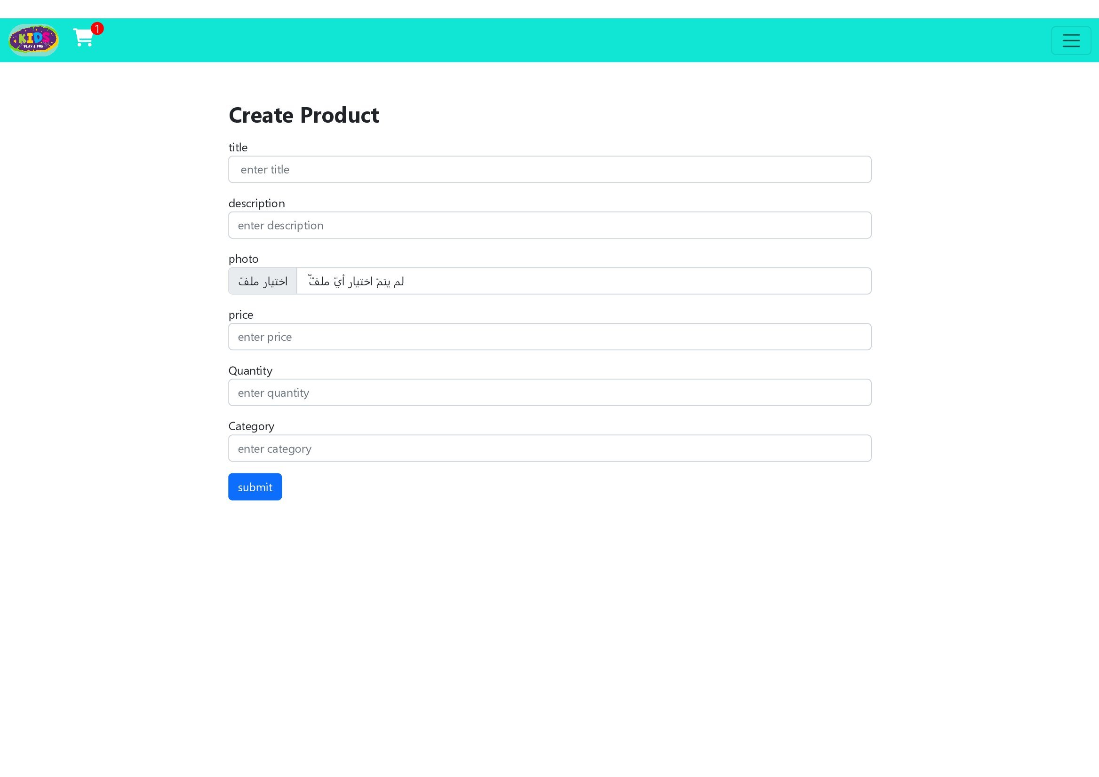

Information page :

1-has the information about project(GOALS ,VISSION ,MISSION .etc…)

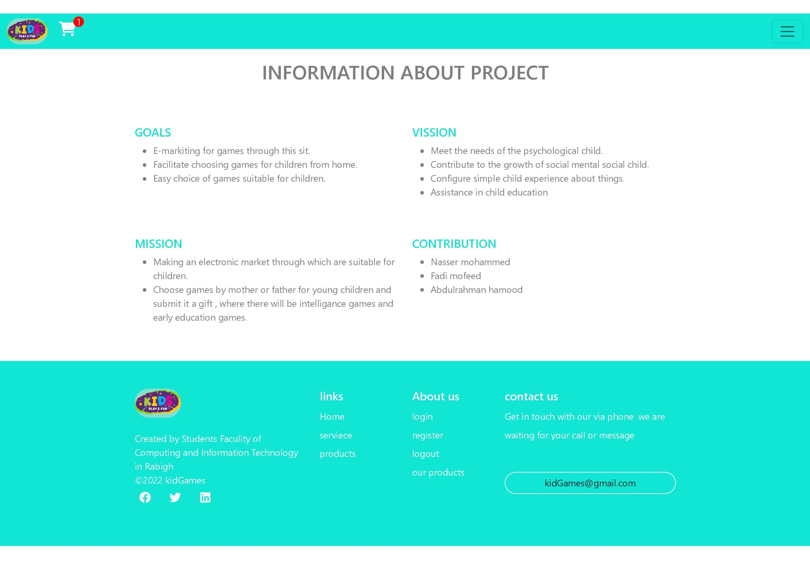

Explain project page:

1-explain all pages and other minds of projects

